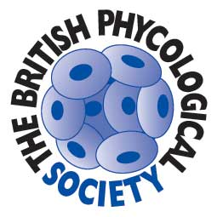

**59th Winter Meeting, Cardiff 2011**

The provisional programme for the 59th Winter Meeting of the British Phycological Society, Cardiff, Wednesday 5th and Friday 7th January 2011, is complete and will accompany the 3rd circular shortly.

**Wednesday 5th January**

* Council meeting
* Registration,
* Special Session 1: Phagotrophy in the Evolution and Ecology of Algae Chair: Prof. John Raven
* Wine and Cheese Poster Session

**Thursday 6th January**

* Special Session 2: The Phycology of Estuaries, Barrages and Lagoons Chair: Prof. Martin Wilkinson
* Presidents Address: Stardust and a story of phycological enlightenment
* Open sessions 1: Microalgae and 2: Macroalgae
* Evening Dinner: Madeira’s Restaurant including the light-hearted quiz (organised by N. Ginnever) and the Auction (organised by Elliot Schubert)

**Friday 7th January**

* Manton Session
* Open sessions 3: Microalgae and 4: Freshwater microalgae
* Hilda Canter-Lund Prize award ceremony (Martyn Kelly)
* A tribute to Prof. Frank Round
* BPS Annual general Meeting
* Conference Banquet (Parc Thistle Hotel)

In total there are 46 oral presentations and 20 posters to be presented.

**Please get thinking and searching for items suitable for Elliot to sell at the Auction.**

**REMINDER – FINAL REGISTRATION IS 12TH DEC (REGISTRATION FORM IS ON THE BPS WEBSITE WITH THE ADDRESS OF WHERE TO SEND IT).**