PhD candidates 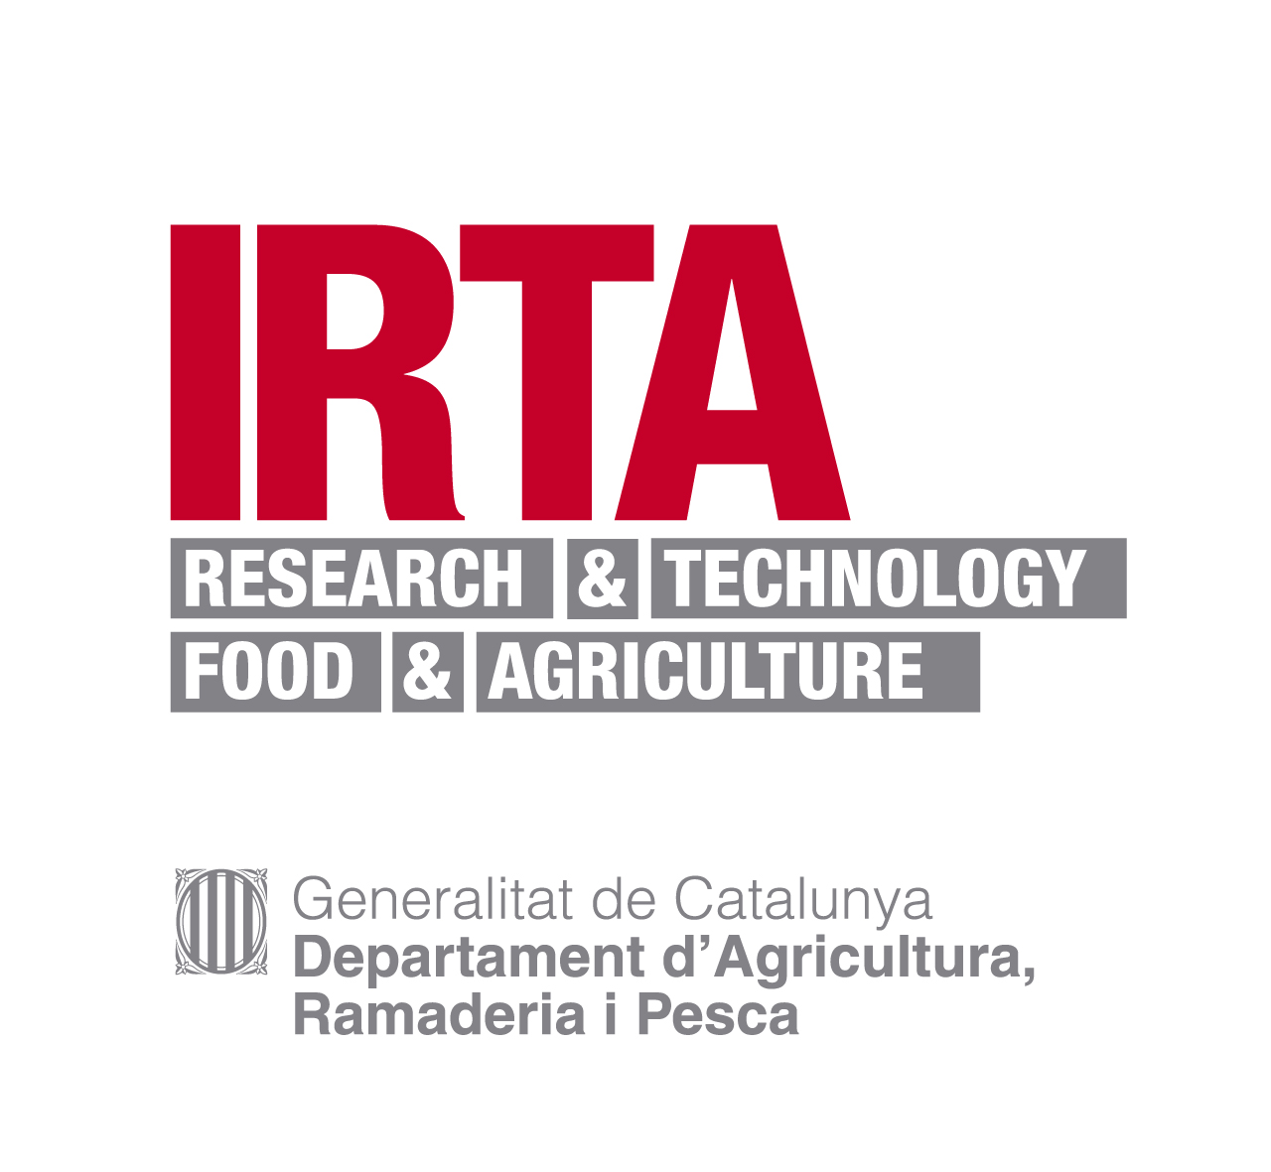

We are seeking for possible PhD candidates for future scholarships applications.

The candidate will present a grant application to open calls, depending on the country of origin and present situation. The research will start immediately after obtaining the grant. Financing through future projects may also be possible.

Institution: IRTA (Institut de Recerca i Tecnologia Agroalimentàries)

Location: Ctra. Poble Nou, km. 5.5
43540 Sant Carles de la Ràpita (Tarragona, Spain)

Title: Development of biosensors for the detection of aquatic toxins

Job description:
- Multidisciplinary PhD in the areas of biotechnology, molecular biology, analytical chemistry, electrochemistry, microelectronics and nanotechnology.
- Development of electrochemical and optical enzyme sensors, immunosensors and aptasensors for the detection of aquatic toxins in microalgae cultures and shellfish. Implementation of biosensors in food safety programmes.
- Interdisciplinary team.
- Possibility to inscribe the thesis in several universities.
- Possibility to do research stages at foreign laboratories.

Requirements:
- Profile: Biology, Biochemistry, Biotechnology, Chemistry, Pharmacy, Medicine, Veterinary or Marine Science.
- Good academic expedient
- Good English level

Application:
Send CV, motivation letter and academic expedient to:
Dr. Mònica Campàs
monica.campas@irta.cat

This is not a job offer; this is a search for potential PhD candidates.

