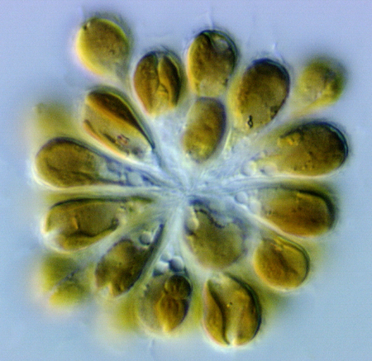 | Seventh International Chrysophyte Symposium  Connecticut College  June 22-26, 2008

Registration Form

First Name
Surname
Institution
Mailing Address
City, State, Zip Code
Country
Phone No.
Fax No.
Email
Preferred name for conference badge

Conference Registration Fees

Notes about registration and conference costs:

Registration fee - Includes attendance at all sessions and conference activities, use of special rooms, the field trip (transportation and entry fee), and abstract packets. One-day registration fee gives the same privileges only for that day.

Conference Meals - Some participants have noted that they do not want to pay for three meals a day. With this in mind, we have planned to divide meals into two parts. The first part will be mandatory and include all of the dinners, Wednesday lunch, all coffee/soda/juice served between sessions and light snacks with the Poster session. The dinners will be catered and served such that we will dine as a group and stay near the building where the talks and activities will be held. This way, the group can easily return for evening events.

Each dinner will have meat and vegetarian options. Wednesday evening is our special New England Clam Bake. If you wish to include a lobster for an additional fee with the Clam Bake please select that option below. Participants should also choose from the three options for the Thursday night banquet listed below.

The second part includes breakfasts and lunches which will be served in the primary Dining Room associated with the dorm complex where participants will stay. We have arranged it so participants can purchase a pass for four breakfasts and three lunches for $48. Alternatively, participants could elect not to pay the $48 at registration and pay a-la-carte as they go. This gives people the option not to pay for meals if, for example, they don’t want breakfast each morning. A-la-carte costs are $6 for breakfast and $9 for lunch. Numerous selections are offered and the price is for all you can eat.

Lodging - Lodging will be offered at two rates: $150 for five nights or $40/night for an individual night. Rooms are single occupancy, new, air-conditioned and include linens.

Figuring Your Payment

1. Registration Fee - Circle One:

A. Standard Registration Fee - $150
B. One Day registration Fee - $75

2. Food Part I - Circle One:

A. Conference Breaks, Dinners, Clam Bake (without lobster) & Banquet - $120

B. Conference Breaks, Dinners, Clam Bake (with lobster) & Banquet - $138

3. Food Part II - Circle One:

A. Breakfasts (4) & Lunches (3) - $48

B. I prefer to pay for Breakfasts & Lunches separately

4. Lodging - Circle One:

A. Lodging for Five nights (Sunday through Thursday) - $150

B. Circle the nights you wish to stay and multiply the number by $40 per night:

Sunday Monday Tuesday Wednesday Thursday

C. I will secure my own lodging accommodations.

Total for lodging: $________

5. Add up your total costs and enter here: $_________

6. Thursday Banquet Options – Please Circle One of the Following:

A. Grilled Salmon with Citrus Salsa

B. Beef Tenderloin with Citrus Salsa

C. Grilled Portabella Mushroom Cap with Citrus Salsa

6. Field Trip Option - Please select One. See ICS website for more details:

A. Mystic Seaport

B. Yale Peabody Museum

7. Will there be another person accompanying you?

If your answer is “Yes”, please contact Anne Lizarralde at “aliz@conncoll.edu” so we can calculate specific costs.

Payment method
Please note that credit cards are the preferred method of payment. Upon receipt of your credit card information below, an email will be sent back to you to indicate that we have charged your account. Although we will accept personal checks drawn on US banks, we will not for foreign banks because of associated bank charges assessed when cashing the check. If you have any questions, please contact us.
1. Credit Card Information:
Circle Card Type: VISA MasterCard Discover
Name on card:
Card Number:
Expiration Date:
Address of Card Holder:
3-digit Security Code on back of card:
2. Personal check (US banks only): Make check payable to “Connecticut College” and list “ICS 2008” in the memo line.

Presentations - Abstracts are due by May 1, 2008
All participants are invited to present one oral presentation and/or a poster presentation. Please see the conference website link to view/download the Abstract template and details concerning presentation requirements.
Circle the type(s) of presentation(s) you plan to make:
Oral Presentation
Poster Presentation
Participants may present more than one poster. If If you would like to present more than one oral presentation, please contact us via e-mail. This will depend on availability within the paper sessions.

Submit Completed Registration Form - Deadline April 15, 2008

Please submit your registration form using one of the following methods:

Mail to: Anne Lizarralde, Connecticut College, Box 5604, 270 Mohegan Avenue, New London, CT, 06320-4196 USA

FAX to 860-439-2519, Attention to Anne Lizarralde and Peter Siver

Email as attachment to aliz@conncoll.edu with REGISTRATION in the subject heading. If you elect this option, please be sure that your selections are clearly noted.

