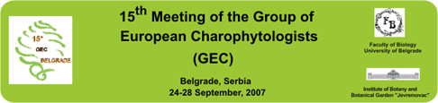

PRE-REGISTRATION FORM:

NAME:
ADDRESS: COUNTRY:
PHONE: FAX:
E-MAIL:

IRGC-Member Non IRGC-Member Student
Accompanying member
I intend to present: Oral presentation Poster
Provisional Title :

I will attend the Scientific sessions (24-25 Sept.)
I will attend the 3 day Post-Symposium field trip: Yes

PLEASE, return NO LATER than April 30, 2007
To
Dr Jasmina -Sekulic

Institute of Botany and Botanical Garden “Jevremovac”
Faculty of Biology, University of Belgrade
Takovska 43
11000 Belgrade, Srebia
Tel: +381 11 32 44 923 Fax : +381 11 32 43 603
jsekulic@bfbot.bg.ac.yu

